Dictionary View Objects
The objects returned by dict.keys(), dict.values() and dict.items() are view objects. They provide a dynamic view on the dictionary’s entries, which means that when the dictionary changes, the view reflects these changes.

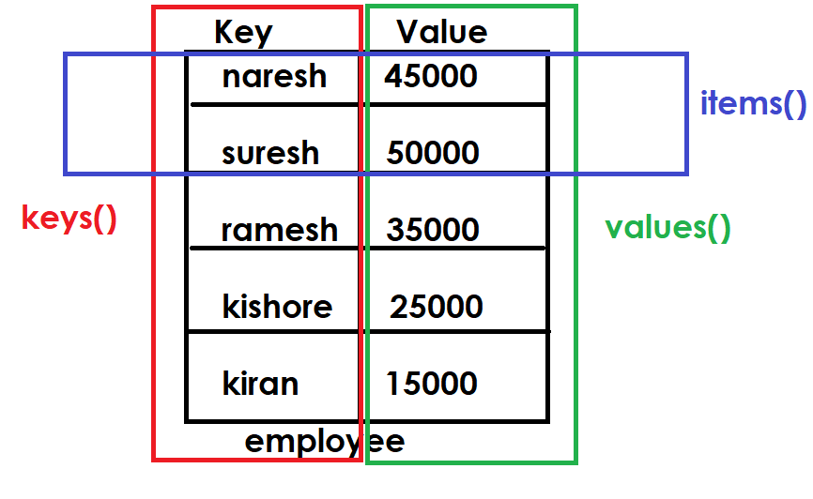
Example:
employee={'naresh':45000,
'suresh':50000,
'ramesh':25000,
'kiran':15000}

print(employee)
names=employee.keys()
print(names)
for name in names:
print(name)
salaries=employee.values()
print(salaries)
for sal in salaries:
print(sal)

emp=employee.items()
print(emp)
for e in emp:
print(e)

Output
{'naresh': 45000, 'suresh': 50000, 'ramesh': 25000, 'kiran': 15000}
dict_keys(['naresh', 'suresh', 'ramesh', 'kiran'])
naresh
suresh
ramesh
kiran
dict_values([45000, 50000, 25000, 15000])
45000
50000
25000
15000
dict_items([('naresh', 45000), ('suresh', 50000), ('ramesh', 25000), ('kiran', 15000)])
('naresh', 45000)
('suresh', 50000)
('ramesh', 25000)
('kiran', 15000)

setdefault(key, default=None, /)
If key is in the dictionary, return its value. If not, insert key with a value of default and return default. default defaults to None.

>>> dict1={}
>>> print(dict1)
{}
>>> v1=dict1.setdefault(1)
>>> print(dict1)
{1: None}
>>> print(v1)
None
>>> v2=dict1.setdefault(1)
>>> print(v2)
None
>>> v3=dict1.setdefault(2,20)
>>> print(v3)
20
>>> print(dict1)
{1: None, 2: 20}

reversed(d)
Return a reverse iterator over the keys of the dictionary.

Example:
dict1=dict(zip(range(1,6),range(10,60,10)))
print(dict1)

for k in reversed(dict1):
print(k,dict1[k])

Output
{1: 10, 2: 20, 3: 30, 4: 40, 5: 50}
5 50
4 40
3 30
2 20
1 10

Mutable Operations of dictionary
After creating dictionary changes can be done using mutable operations.

- Adding or Updating an item within dictionary

Syntax1: dictionary-name[key]=value

This syntax perform 2 operations
- If key exists, it replace/update value
- If key not exists, it add key with value

Example:
>>> dict1={}
>>> dict1[1]=10
>>> print(dict1)
{1: 10}
>>> dict1[2]=20
>>> print(dict1)
{1: 10, 2: 20}
>>> dict1[3]=30
>>> print(dict1)
{1: 10, 2: 20, 3: 30}

# Write a program to read the scores of n players and display
# store player details into dictionary
# each player having name and runs

n=int(input("How many players?"))
players={}

for i in range(n):
name=input("PlayerName :")
score=int(input("PlayerScore :"))
players[name]=score

print(players)

Output
How many players?2
PlayerName :Rohit
PlayerScore :100
PlayerName :Virat
PlayerScore :89
{'Rohit': 100, 'Virat': 89}

# Write a program to read sales of n sales persons
# calculate total sales, max sales, min sales
# each sales person having name,sales
n=int(input("How many sales persons?"))
sales={}

for i in range(n):
name=input("Enter Name :")
s=float(input("Enter Sales :"))
sales[name]=s

print(f'Sales : {sales}')
print(f'Total Sales : {sum(sales.values())}')
print(f'Maximum Sales :{max(sales.values())}')
print(f'Minimum Sales :{min(sales.values())}')

Output
How many sales persons?5
Enter Name :aaa
Enter Sales :45000
Enter Name :bbb
Enter Sales :20000
Enter Name :ccc
Enter Sales :60000
Enter Name :ddd
Enter Sales :35000
Enter Name :eee
Enter Sales :22000
Sales : {'aaa': 45000.0, 'bbb': 20000.0, 'ccc': 60000.0, 'ddd': 35000.0, 'eee': 22000.0}
Total Sales : 182000.0
Maximum Sales :60000.0
Minimum Sales :20000.0

Replacing or Updating values
Dictionary keys are immutable but values are mutable

>>> dict1={1:10,2:20,3:30,4:40,5:50}
>>> print(dict1)
{1: 10, 2: 20, 3: 30, 4: 40, 5: 50}
>>> dict1[1]=99
>>> print(dict1)
{1: 99, 2: 20, 3: 30, 4: 40, 5: 50}
>>> dict1[3]=77
>>> print(dict1)
{1: 99, 2: 20, 3: 77, 4: 40, 5: 50}
>>> dict1[5]=100
>>> print(dict1)
{1: 99, 2: 20, 3: 77, 4: 40, 5: 100}
>>> dict1[7]=200
>>> print(dict1)
{1: 99, 2: 20, 3: 77, 4: 40, 5: 100, 7: 200}
>>>

update(**kwargs)
Update the dictionary with the key/value pairs from mapping or iterable and kwargs, overwriting existing keys. Return None.

>>> d1={1:10,2:20}
>>> print(d1)
{1: 10, 2: 20}
>>> d1.update({3:30,4:40,5:50})
>>> print(d1)
{1: 10, 2: 20, 3: 30, 4: 40, 5: 50}
>>> d1.update({3:100,1:200,6:60,7:70})
>>> print(d1)
{1: 200, 2: 20, 3: 100, 4: 40, 5: 50, 6: 60, 7: 70}

Removing or deleting items from dictionary
Items can be removed or deleted from dictionary using different methods provided by dictionary

- Using “del” keyword
- Using remove method
- Using clear method
- Using pop method
- Using popitem method

